- XRD衍射仪 Bruker D8 Advance ：Bruker Corporation
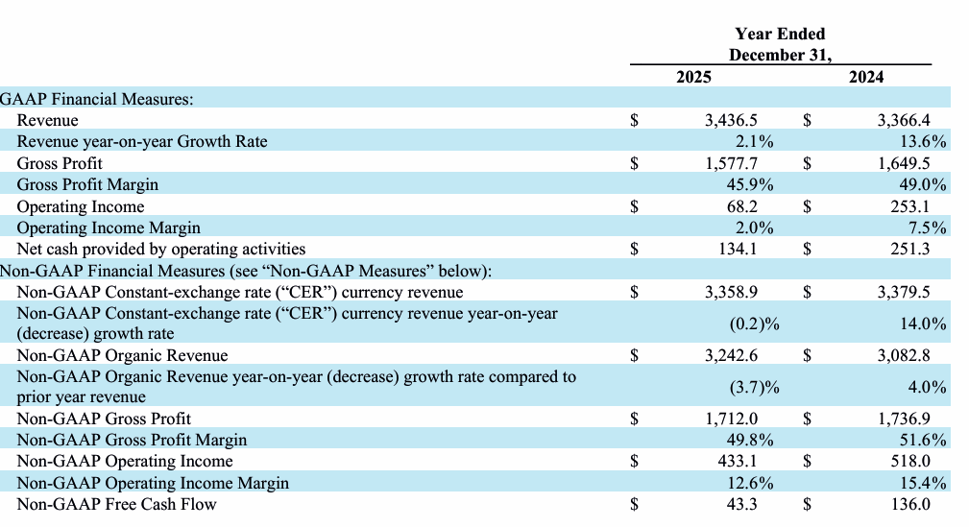
数据来源：Bruker Corporation - Financial Info - Quarterly Results
- XRF荧光光谱 Bruker S8 Tiger ：Bruker Corporation
- 拉曼光谱仪：Renishaw inVia ：Renishaw plc
数据来源：This is Money
- 质谱联用系统 hermo Q Exactive ：Thermo Fisher Scientific Inc
数据来源：赛默飞世尔科技_F10
Quarterly report [Sections 13 or 15(d)] _ 赛默飞世尔科技(TMO) _ 公告正文

